**Ex1-5 – Creating and populating Dim_TIME on DW-Layer**

* + Physical diagram



**Ex6 – Dimensions Types**

Next points are mandatory:

* Start scheme must use no less one of SCD type 2 Dimension
* Start scheme must use prepared dimensions: DIM_TIME, DIM_LOCATIONS
* Start scheme must use one of period dimensions: DIM_GEN_PERIODS

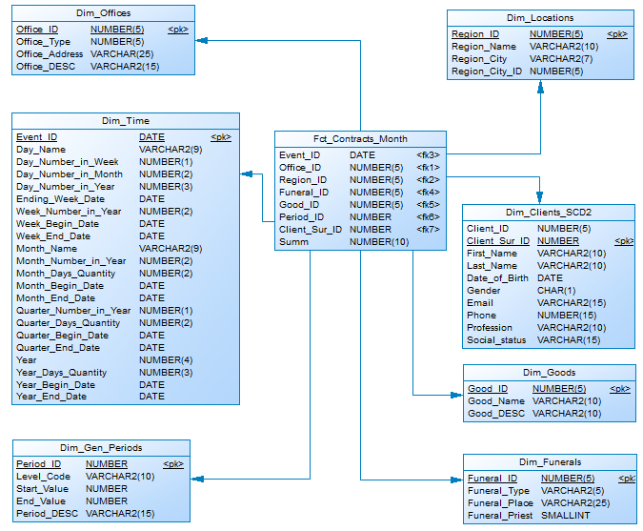

|  |  |  |  |  |
| --- | --- | --- | --- | --- |
| **Name** | **Type** | **Size** | **DW – Merged Dimensions** | **Descriptions** |
| Dim_Time | SCD1 | BIG | DW.T_DAYS, DW.T_WEEKS, DW.T_MONTHS, DW.T_QUARTERS,  DW.T_YEARS | Stores all information about dates of our contracts |
| Dim_Clients_SCD2 | SCD2 | BIG | DW.T_Clients  DW.T_Professions | Here detailed info about clients, their professions and statuses stores |
| Dim_Offices | SCD1 | SMALL |  | Dimension stores information about all of the offices the company has |
| Dim_Funerals | SCD1 | SMALL |  | Here detailed info about funeral stores (type, place, with a priest or no) |
| Dim_Goods | SCD1 | SMALL |  | Stores info about ritual goods the company sales |
| Dim_Locations | SCD1 | SMALL | DW.T_Regions  DW.T_Cities | Here we keep information about cities where funeral were provided and offices are situated |
| Dim_Gen_Periods | SCD1 | SMALL | DW.T_PERIOD_DESC  DW.T_PER_START  DW.T_PER_END  DW.T_LEVEL_CODE | Specific type of dimension, which allows grouping of facts on the basis of logic (the age of clients). |

**Ex7 – Dimensions** **Hierarchies**

**DIM_GEN_TIME**

**Hierarchy DAY – WEEK – MONTH – YEAR**

|  |  |  |  |
| --- | --- | --- | --- |
| **Name** | **LEVEL_CODE** | **LEVEL_DESC** | **LEVEL_NATURAL_KEY** |
| DAYs | DAY | Store all day at the calendar | DAY_ID |
| WEEKs | WEEK | Store all weeks at the calendar year | WEEK_ID |
| MONTHs | MONTH | Store months at the calendar year | MONTH_ID |
| YEARs | YEAR | Store years at the calendar year | YEAR_ID |

**Hierarchy DAY – MONTH – QUARTER –YEAR**

|  |  |  |  |
| --- | --- | --- | --- |
| **Name** | **LEVEL_CODE** | **LEVEL_DESC** | **LEVEL_NATURAL_KEY** |
| DAYs | DAY | Store day at the calendar year | DAY_ID |
| MONTHSs | MONTH | Store months at the calendar year | WEEK_ID |
| QUARTERs | QUARTER | Store quarters at the calendar year | QUARTER_ID |
| YEARs | YEAR | Store years at the calendar year | YEAR_ID |

**DIM_Locations**

**Hierarchy CITY – STATE**

|  |  |  |  |
| --- | --- | --- | --- |
| **Name** | **LEVEL_CODE** | **LEVEL_DESC** | **LEVEL_NATURAL_KEY** |
| Cities | City | Store all the cities for each state | State_City_ID |
| STATEs | State | Store all the states of the country | State_ID |

## Ex8 – Facts Aggregations

|  |  |  |  |  |
| --- | --- | --- | --- | --- |
| **Name** | **Code** | **Table Name** | **Additive** | **Descriptions** |
| Counts sums of contracts | Summ_of_contract | Fct_Contracts | + | Calculate distinct values of company’s sums of contracts at the period. |